

The Palmer Family has set up several donation options to honor Danny. It is important to the family that donations benefit the community in a meaningful way. We have chosen 3 options that we feel Danny would approve. Thank you for being so considerate.

**Option 1**

Danny loved animals and always had a soft spot in his heart for domesticated animals. The first option is the Humane Society of Southern Arizona. Should you choose, please consider donating to the Humane Society of Southern Arizona in honor of Danny’s memory. You may scan the QR Code with your camera or click the link.



<https://support.hssaz.org/campaign/698010/donate>

**Option 2**

Danny played baseball for Rincon Little League for seven seasons before playing club ball for the Tigerz. He also played in middle school and high school. He was happiest as a young player, and the Rincon Little League was a huge part of his childhood. The family would like to assist with registration fees and other needs for the league in Danny’s name. Please consider donating to the Rincon Little League in Danny’s memory. This donation is through Zelle. You may scan the QR Code below to donate.

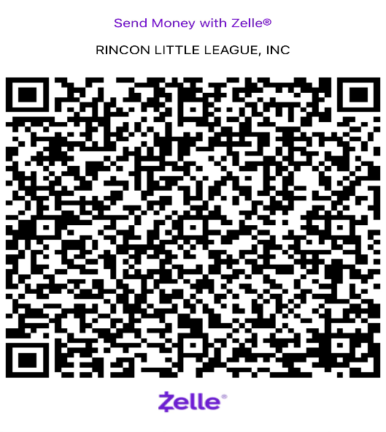

**Option 3**

Danny and his family have attended Pantano Christian Church for the past 10 years. Pantano’s ministries support local, national, and international efforts spreading the word of the Gospel. The outreach and support toward the community provided by Pantano is extraordinary. Please consider donating to Pantano Christian Church in Danny’s name. Click on the QR code below to donate.

